PROJECT DEVELOPMENT PHASE

MODEL PERFORMANCE TEST
Date: 02 October 2026
Team ID: 6ab6898e02319e850fcda6c8
Project Name: Script-Controlled Access Control List (ACL) Security Platform
Maximum Marks:

Model Performance Test Evaluation

S.No. | Parameter | Screenshot / Values
1. | Data Rendered | ACL rules, user details, IP addresses, access permissions, resource details and access logs are successfully rendered in the dashboard.
2. | Data Preprocessing | Data is validated, duplicate records are removed, missing values are handled, and ACL data is formatted before processing.
3. | Utilization of Data Filters | Filters are used for User, IP Address, Resource, Permission, Access Status and Date/Time to analyze ACL records.
4. | DAX Queries Used | DAX measures are used to calculate Total Users, Total ACL Rules, Allowed Requests, Denied Requests and Access Rate.
5. | Dashboard Design | No. of Visualizations / Graphs – 6
6. | Report Design | No. of Visualizations / Graphs – 5

Dashboard & Report Visualizations Breakdown

Dashboard – 6 Visualizations
- 1. Total Users
- 2. Total ACL Rules
- 3. Allowed Requests
- 4. Denied Requests
- 5. Access Status Chart
- 6. Access Logs by Date/Time

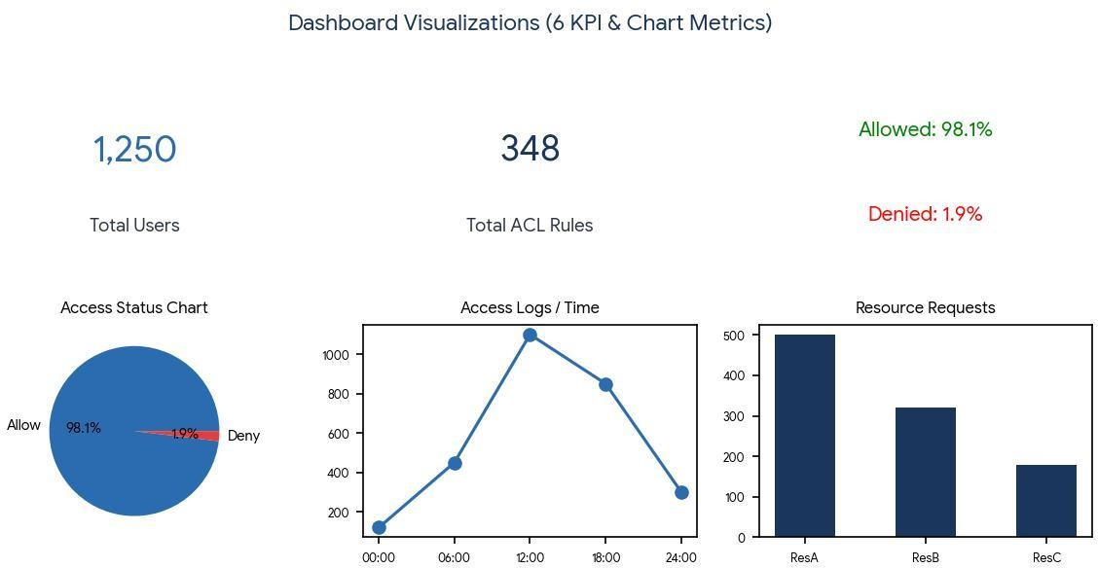

Report – 5 Visualizations
- 1. User-wise Access Report
- 2. Resource-wise Access Report
- 3. Allowed vs Denied Requests
- 4. ACL Rule Summary
- 5. Access Log Analysis
